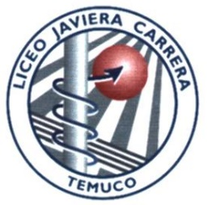
GUÍA Nº: 02
CURSO: SEGUNDO MEDIO A Y B ASIGNATURA: QUÍMICA
PROFESORA: ESTER ORTIZ SALDÍAS

UNIDAD N°1: Priorización N1

NOMBRE ESTUDIANTE |  | CURSO | 4° Medio ______________
ASIGNATURA | Inglés | SEMANA N°1 | A01/12 al 29/ ABRIL/2021
PROFESOR | Hector Quintul

Tema: What to major in?
OA 3
Utilizar su conocimiento del inglés en la comprensión y producción de textos orales y escritos claros, con el fin de construir una postura personal crítica en contextos relacionados con sus intereses e inquietudes.
Indicadores
Organizan información explícita de los textos leídos; por ejemplo: hacen clasificaciones.
Identifican información en páginas web relacionadas con temas tratados en la clase.
Usan material de referencia (diccionario en papel o digital, internet) para apoyar la comprensión. Escriben textos variados.
Organizan ideas antes de escribir.
Corrigen y editan sus propios textos y los de otros para mejorar claridad, organización, precisión de contenidos, párrafos, vocabulario y estructuras de oraciones, usando criterio de evaluación.
Demuestran manejo en el uso de las TIC para corregir, editar y publicar textos

ACTIVIDAD DE APRENDIZAJE N°2


WHAT SHOUD I MAJOR IN?

Estimados estudiantes:

Esta guía tiene como propósito dar a conocer las instrucciones y etapas la segunda actividad del año en la asignatura. El objetivo de este trabajo es principalmente desarrollar y trabajar de comprensión lectora a través del resumen de un texto a infografía.

Plazos de entrega:
1° AVANCE: LUNES 12-16 abril
2° AVANCE: LUNES 19 – 23 abril
FECHA DE ENTREGA PRODUCTO FINAL: 29 DE ABRIL

Dudas o comentarios a: hquintul@liceojavieracarrera.cl

Para la mejor realización y corrección de cualquier trabajo escrito en inglés se sugiere utilizar los siguientes recursos web:
Diccionario: https://www.wordreference.com/

Editor de textos en inglés: https://app.grammarly.com/

ETAPAS Y SUS AVANCES
1° Avance | Resolver de Diagraman
2° Avance | Entrega de modelo de Infografía
3° Producto Final | Entrega de infografía final con mejoras.


WHAT SHOULD I MAJOR IN?

- IDENTIFY INTERESTS, VALUES, PASSIONS AND ABILITIES

“What major should I choose?” “What major is right for me?”

  BASED ON ABILITIES: Abilities are what you are able to do, generally speaking. Understanding what areas you have skills is a great way to start the process when choosing a university major. However, don’t discount the fields where you lack ability just yet; you’ll be able to build those up more during your studies - it is a place to learn, after all. |   BASED ON VALUES: Choosing a major based on your core beliefs will normally lead to work that is more rewarding and encouraging. However, don’t look too hard at your values when choosing a major, either. University is a time of experimentation and self-discovery, and most people solidify their values during their college years.
  BASED ON INTERESTS: Your interests are a fine way of determining which major to choose in college. I mean, if you like doing something, why not get paid for it, right? Just remember that, as with your values we previously mentioned, your interests may change over time. |   BASED ON PASSIONS: At first glance, your passions seem just like interest areas, only stronger. However, they also incorporate your values and abilities into something that becomes a burning, lifelong desire. Following your passions, whatever they may be, is one of the best ways to choose a major, and it generally has the least second-guessing later on. However, as with your interests, passions may be defined later on, even after university is over.

.
WILL IT BE AROUND LATER IN LIFE? We live in a time of unrelenting technological progress and innovation. Artificial intelligence and automation are changing the game right now, and it’ll only be more so in the future.
You might have answered that, yes, it is employable, but will it stay that way for decades to come? Employment staples such as accounting are no longer a safe bet.

2. CONSIDER TH E FUTURE


IS IT EMPLOYABLE? In other words, will you be able to easily and readily find employment in a related field after you earn the degree? Avoid the possible discouragement from employment rejection later on by considering a broader field of study rather than something super niche.

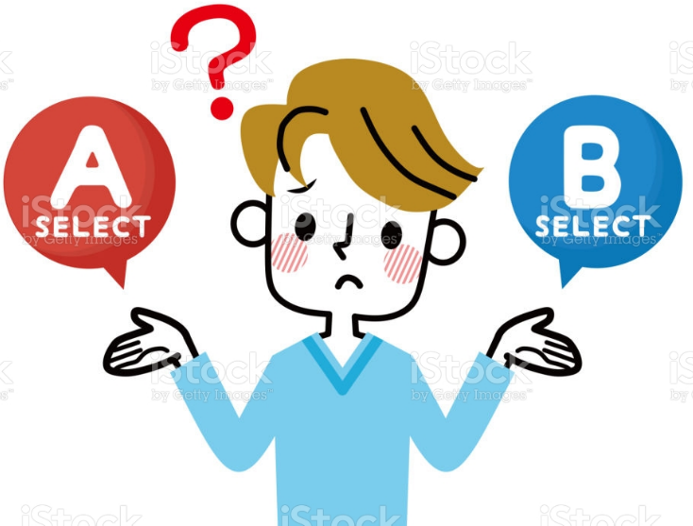

WILL YOU STILL ENJOY IT YEARS FROM NOW?
You have interests and passions and these ideas that you value. But what’s to stop you from switching positions or changing your mind? Who’s to say how you’ll feel even 10 years from now - not to mention 20 or 30 years from now?

WILL IT PAY? You might be the most adamant while saying that money doesn’t rank high in your decision-making process when deciding which major to pick. But let’s be honest - it does matter.


3. CHOOSE THE RIGHT SCHOOL
While there are some schools, like Harvard and Yale, whose alumni are held in high esteem no matter what, most of us attend universities that are great in particular areas.

4. GIVE YOURSELF TIME


Even if you are entering university, most schools and their advisors recommend that you wait before declaring a major. In the U.S., it is common to leave the declaration of your intended major until the end of your sophomore year.
UCLA conducted a national survey in which they found that over 20% of students who had a major chosen upon entering university had already changed their minds by the end of their first year.
If you are nearing that sophomore year’s end and are still undecided as to what you’d like to major in, don’t worry. You’re not the first, and you surely won’t be the last.
5. GET HELP

Who better to help you decide how to choose a major than the college advisors whose main job it is to do so?
Meeting with the university advisor will offer you more in return than just advice on which major is right for you - with their intimate knowledge of the specific university and campus, they can curate just the right course of study for each student.
If you’re researching your major way in advance, you could ask your high school counselor or advisor to guide you with the process.
Talk to your parents. - they’ve been there for you these last couple of decades, and so far, they seem to have your best interest at heart.
6. SPOT ANY DISADVANTAGES BEFORE CHOOSING A MAJOR

Yes, every major that you choose will have some downsides and disadvantages.
DETERMINE HOW LIKELY YOU’LL BE TO SWITCH MAJORS. Many students switch their majors and change their minds throughout their university studies.
HOW WILL I BE AFFECTED AFTER I FINISH THE PROGRAM? Make sure that you understand the costs, the future job market, and the locations you may have to relocate to advance your career.

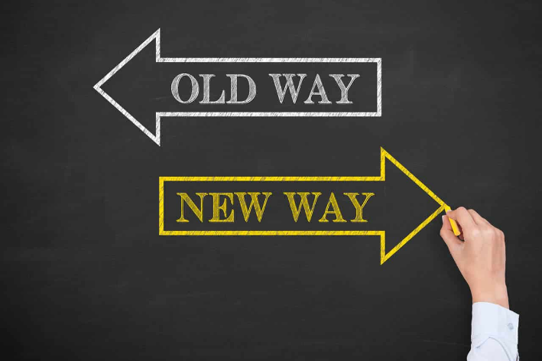
7. CHANGE YOUR MIND

You may decide that the major you chose is not right for you anymore.
Don’t worry about this - you’re not alone. According to the NY Times, a whopping 61% of the students at the University of Florida change their minds on their major by the end of the sophomore year. As you can see, you’d be in the minority if you didn’t second-guess yourself.

PRIMER AVANCE, LEA ATENTAMENTE EL TEXTO ANTERIOR Y COMPLETE EL SIGUIENTE DIAGRAMA
YOUR BELIEFES IS MORE REWARDING
STUDY THE FIRST YEAR, AND DECIDE AT THE END TO CHANGE OR NOT.
FIND THE UNIVERSITY WHICH IS GREAT IN YOUR AREA.

WHAT I AM GOOD AT?
ASK PEOPLE IF YOU HAVEN’T DECIDED YET
EARNING MONEY ON WHAT I LIKE DOING?
BASED ON
PICK
A MAJOR?

INCORPORATE YOUR VALUES AND ABILITIES?
61% OF THE STUDENTS DO IT, IT´S NORMAL
CONSIDER THE FUTURE

I LIKE IT NOW, WILL STILL BE THE SAME IN A FEW YEARS?
WILL I FIND A JOB AFTER I GET MY DEGREE?
YOU MIGHT THINK IT DOESN’T MATTER, BUT IT DOES.
TECHNOLOGY IS CHANGING RIGHT NOW; WILL IT STILL EXIST?

SEGUNDO AVANCE Y TRABAJO FINAL.
EN ESTA OCASIÓN ESCRIBIREMOS UNA INFOGRAFIA.

¿QUÉ ES UNA INFOGRAFIA Y PARA QUÉ UTILIZARLA?

Una infografía es una interesante y llamativa colección de imágenes o gráficos acompañado texto simple pero potente que resume un tema para que se pueda entender fácilmente.

¿POR QUÉ UTILIZAR INFOGRAFÍAS?

Las infografías son excelentes para ayudarnos a procesar más fácil información compleja. Pueden ser muy útiles al momento de:

- Ofrecer un rápido resumen sobre un tema.
- Explicar un proceso complejo.
- Presentar los resultados de una investigación o los datos de una encuesta.
- Resumir una publicación larga o un informe.
- Comparar diferentes opciones.
- Crear conciencia acerca de una causa o problema.
- DAR SUGERENCIAS

TEMA DE LA INFOGRAFÍA

EN EL SEGUNDO Y TERCER AVANCE DEBERA REALIZAR UNA INFOGRAFIA UTILIZANDO EL TEXTO “WHAT SHOULD I MAJOR IN?” DESTACANDO LOS CINCO CONSEJOS QUE PARA USTED SEAN MAS SGNIFICATIVOS Y RELVANTES, ADEMAS DEBE BUSCAR INFORMACIÓN EN INTERNET QUE RESPALDE SUS ELECCIONES.
SU INFOGRAFIA DEBE CONTENER LOS SIGUIENTES ELEMENTOS:
UN TITULO (CONECTADO DIRECTAMENTE CON EL TEMA DE ESTE TRABAJO)
5 CONSEJOS Y CADA CONSEJO DEBE CONTENER:
-UN BREVE TEXTO
-UNA IMAGEN PERTINENTE A CADA CONSEJO
TAMBIÉN DEBES DISPONER LA INFORMACIÓN DE MANERA QUE SEA LOGICA Y ODENADA DENTRO DE LA INFOGRAFIA.
POR ÚLTIMO, DEBES INCORPORAR TU ESTILO PERSONAL A EL TRABAJO.

UTILICE ESTA PAGINA PARA REALIZAR SU TRABAJO

https://www.canva.com/

Si no pudiese hacerlo en computador, puede realizar su trabajo a mano.

EXAMPLE:
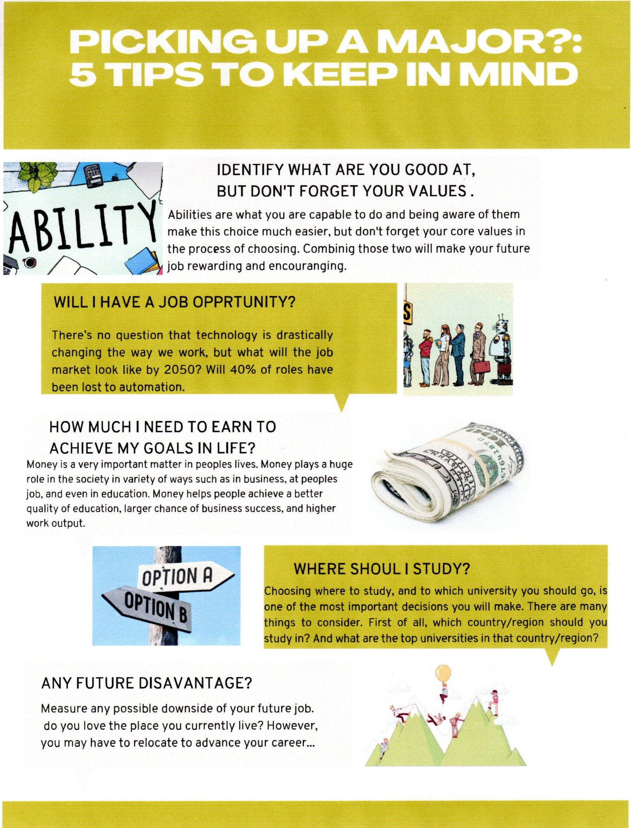
PLAN DE ACTIVIDAD MENSUAL
MONITOREO DEL AVANCE DE LA ACTIVIDAD POR EL ESTUDIANTE

Semana | Actividad de Aprendizaje | Entrega de avances | Monitoreo de avance
Semana | Actividad de Aprendizaje | Fecha se entrega | Entregado | Pendiente | No lo puedo resolver solo
Semana 1 | SOCIALIZACIÓN DE LA ACTIVIDAD | 05/abril/2021
Semana 2 | ENTREGA DEL PRIMER AVANCE – FEEDBACK DEL MISMO | 12/abril/2021
Semana 3 | ENTREGA DEL AVANCE 2 – FEEDBACK DEL MISMO | 19/abril/2021
Semana 4 | ENTREGA FINAL DE LA ACTIVIDAD DE APRENDIZAJE | 29/abril/2021

